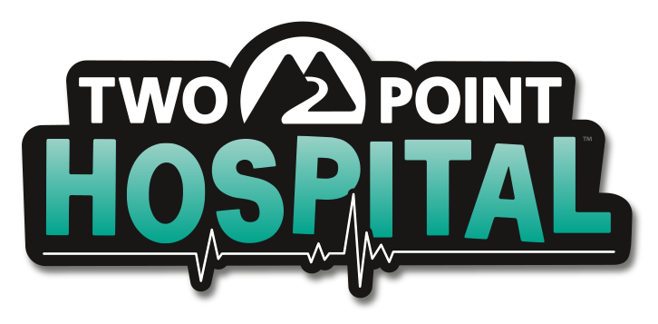

**TWO POINT HOSPITAL OUT NOW ON CONSOLES**

*‘Sandbox Mode’ and ‘The Superbug Initiative’ coming to consoles as a free update 31 March*

We’re pleased to confirm that the humorous management sim Two Point Hospital is out now on PlayStation 4, Xbox One and Nintendo Switch, both digitally and physically. We can now also reveal that the two popular PC features ‘Sandbox Mode’ and ‘The Superbug Initiative’ will be available as a free update across all platforms on 31 March 2020. Check out Two Point Hospital’s launch trailer here: LINK

After a hugely successful PC launch in August 2018, and with over 1 million copies sold so far, Two Point Hospital is now available on consoles, Xbox Game Pass and Xbox Game Pass for PC, with the critics praising the game’s control scheme and its playability across all platforms.

Two Point Hospital has seen many free features added since its PC launch, such as Interior Designer, copy-paste room layouts and character customisation, which have all been made available on consoles. Players that enjoy sandbox play won’t have to wait too long, as both Sandbox Mode and The Superbug Initiative will automatically be added across all platforms on 31 March. In The Superbugs Initiative players collaborate with each other across the globe and complete challenges to unlock new in-game rewards. Finally, Two Point Hospital on consoles will also include two DLC packs, ‘Bigfoot’ and ‘Pebberley Island’, where players can explore new areas and region-specific illnesses.

Visit [www.twopointhospital.com](http://www.twopointhospital.com) to buy the physical edition of Two Point Hospital on PlayStation 4, Xbox One or Nintendo Switch, or head over to the first party store fronts to get the digital version of the game. For more information about all things Two Point Hospital head over to [www.twopointhospital.com](http://www.twopointhospital.com), where you can also sign up for Hospital Pass. You can follow the game on [YouTube](https://www.youtube.com/channel/UCyM2ggE_7Ttc8h0ecy65_mw/featured), [Facebook](https://www.facebook.com/twopointhospital/) and [Twitter](http://www.twitter.com/2PointHospital). For more information about SEGA Europe, log on to [www.sega.co.uk](http://www.sega.co.uk/), follow us on [Facebook](http://www.facebook.com/sega) or on [Twitter](http://www.twitter.com/sega).